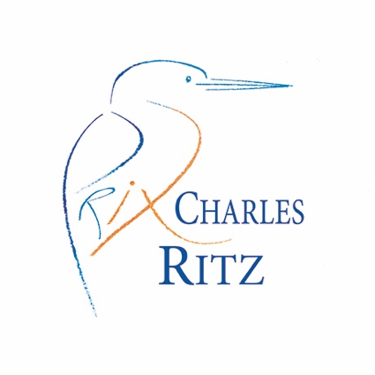
Application form

Cherishing the rivers to which we belong

Each year the Prix Charles Ritz rewards a trophy and a cheque for works undertaken with devotion and commitment by individuals/communities who make a difference to the rivers they cherish.

This year, the Fario Club, London, has established the Prix Charles Ritz award for England and Wales, to honour projects here helping to preserve our rivers for future generations.

All applications with projects undertaken in England and Wales are accepted. Please 4 pages maximum + attachments. You may apply by e-mail to prixcharlesritz@gmail.com by the 31rst August 2019

Name of the Lead Applicant:

Address:

Telephone:

Email:

Individual/ Club / Organisation:

Project name:
Date of completion:
Project objectives – what did you do and why? Why was there a need for the project? [For restoration projects please include location and background)

How have the objectives been achieved? (If appropriate please relevant documents for example before and after photos, monitoring results and/or press coverage)

Guidance

- The award is aimed at restoration projects, large or small, and/or community projects those core objectives are to improve the riverine environment and the species which depend upon them through direct action or education.

- This is the initial application. The jury (judging panel) will compile a short list and visit these projects over the summer. The winner will be notified in early November, and an awards ceremony held beginning of 2020.

Thank you and good luck.

Terms and conditions of entry
Prix Charles Ritz will use the material from any entry or prize winner in its promotional literature, or on its website, or in other publicity as may be appropriate, unless you advise at the time of entry that you do not wish to take part. Copyright in any and all material submitted by the applicant(s) will remain with the applicant(s), although by submitting an entry, the applicant agrees to the organisation using material as described in these terms.
Prize winners agree to attend the Awards Ceremony and presentation.
By entering the Conservation Awards you are providing your information to Prix Charles Ritz and no other party. The information you provide will be used in conjunction with the organisations privacy policy available upon request.

